**Name(s) Surname(s):** Dinilethu Malatse(ST10264831)

Meshack Tshuma( ST10128702)

PHENYO MBANA [ST10341562]

# Module Code: OPSC6311 Assignment: Part1(RESEARCH)

**Introduction:**

Effective personal money management is essential for both financial growth and stability. Budgeting apps are now essential tools in the digital age, enabling users to keep track of spending, establish financial objectives, and understand their spending trends. Three popular Android personal budgeting apps—Goodbudget, Quicken Simplifi, and Rocket Money—are examined in this study. The features, advantages, disadvantages, and innovative elements of each app will be examined. To emphasize the ideal budgeting app functionalities, a visual comparison and a carefully curated list of the best features will also be provided. **1. Goodbudget**

# a. Overview

Using the envelope system, Goodbudget is a straightforward yet powerful budgeting app that helps users organize their spending by breaking down their income into various categories, such as savings, groceries, and rent. Users manually enter transactions rather than connecting to a bank account, which may require a little more work but promotes greater financial awareness and control.

One of Goodbudget’s standout features is shared budgeting, making it a great option for couples or families who want to manage finances together. Users can access their budget from any location because it is accessible through web browsers, iOS, and Android. In order to help users understand where their money is going, the app also offers spending insights and reports. Additionally, users can set aside money to pay off credit card debt or loans using the debt tracking feature.

Goodbudget is ideal for people who want a structured method to manage their finances and prefer a hands-on approach to budgeting, even though it doesn't offer automatic bank syncing.

## *“Goodbudget Home Screen – Overview of the Envelope Budgeting Systems” (Images)*

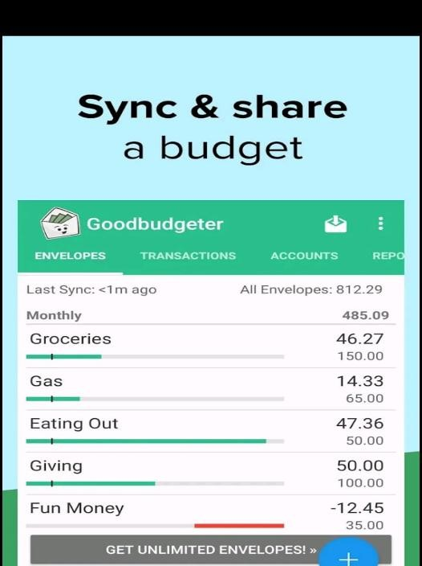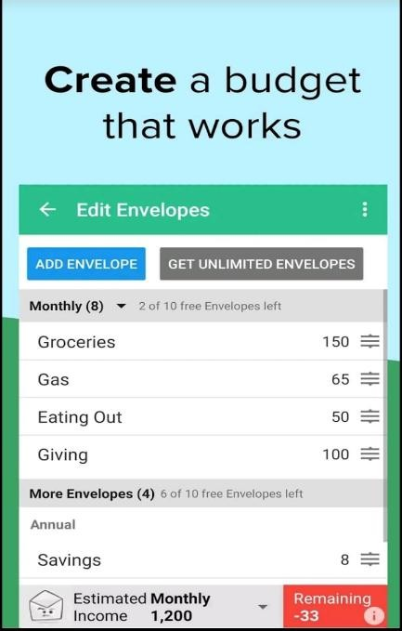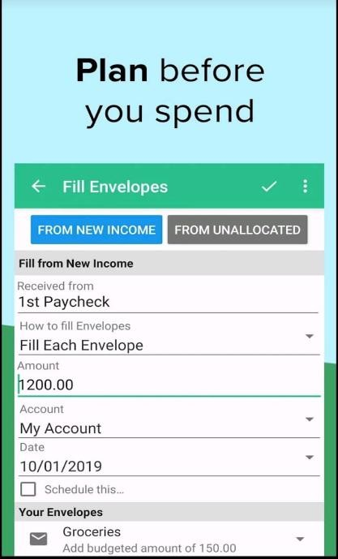

# b. Strengths and Weaknesses

**Strengths:**

* **Envelope Budgeting:** Encourages disciplined spending by allocating money to specific categories.
* **Cross-Platform Availability:** Synchronizes data across multiple devices.
* **Shared Budgeting:** Allows family members to collaborate on budgeting.
* **User-Friendly Interface:** Simple and intuitive, even for beginners.

**Weaknesses:**

* **Manual Data Entry:** Requires users to input transactions manually, which can be timeconsuming.
* **Limited Free Version:** The free version offers only 20 envelopes and one account.
* **No Automatic Bank Syncing:** Lacks integration with bank accounts for transaction tracking.

## c. Innovative Features

* **Debt Tracking:** Helps users plan and monitor debt repayments.
* **Goal Setting:** Allows users to set and track financial goals.

**2. Quicken Simplifi**

# a. Overview

For users who wish to track their finances in real time, Quicken Simplifi is ideal. The app gives users a clear and organized view of their income, spending, and overall financial health by automatically updating transactions through its connections to more than 14,000 financial institutions.

Automation is one of its greatest benefits; rather than requiring you to manually keep track of every expense, Simplifi does it for you by classifying transactions and instantly updating your budget. It also offers customizable spending plans, helping users set limits on different categories and stay on track.

Users can easily track their bills, see where their money is going, and even keep an eye on their net worth over time thanks to its user-friendly dashboard. The app is a fantastic option for people who want comprehensive insights, automation, and hands-free financial management, even though it requires a paid subscription. *Quicken Simplifi Dashboard – Real-Time Financial*

## *Overview.(Images)*

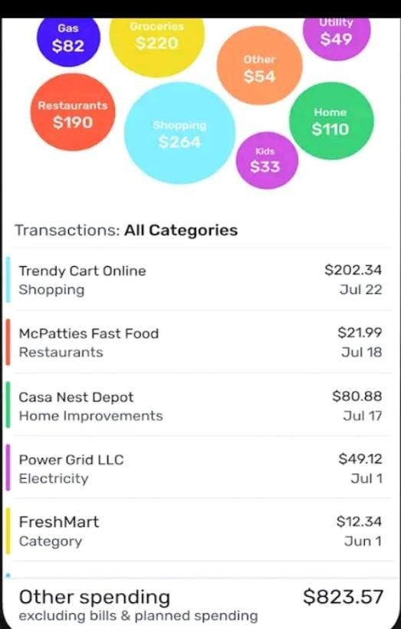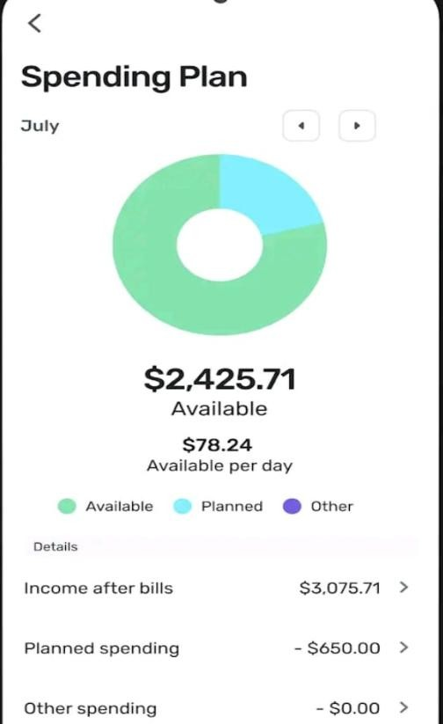

# b. Strengths and Weaknesses

**Strengths:**

* **Automated Transaction Syncing:** Directly integrates with bank accounts for real-time updates.
* **Customizable Spending Plan:** Users can create spending limits for various categories.
* **Comprehensive Financial Overview:** Offers insights into net worth, income, and expenditures.

**Weaknesses:**

* **Subscription-Based Model:** Requires a paid subscription, which may not appeal to budget-conscious users.
* **Occasional Connectivity Issues:** Some users report difficulties in syncing with certain banks.

## c. Innovative Features

* **Real-Time Updates:** Ensures users always have the latest financial data.
* **Custom Watchlists:** Monitors specific spending categories or payees.

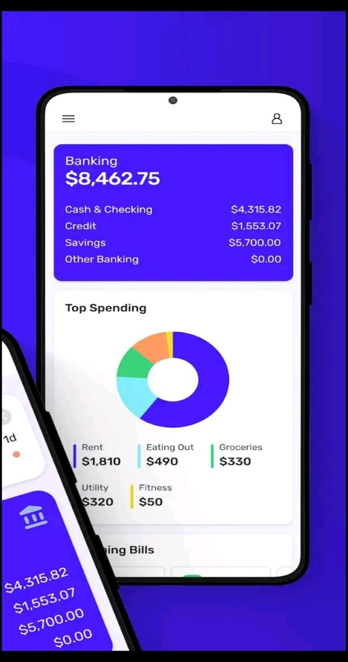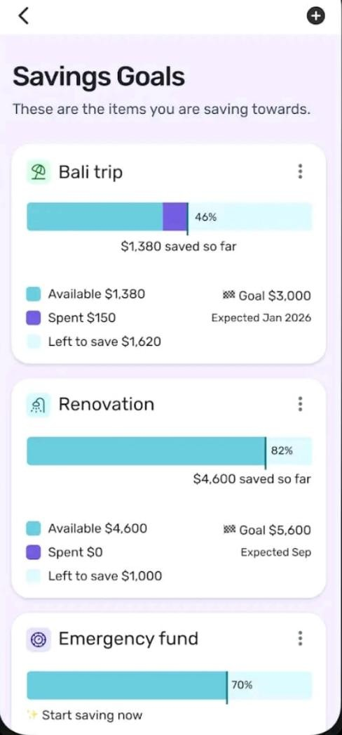

**3. Rocket Money**

# a. Overview

A budgeting app called Rocket Money (formerly Truebill) was created to assist users in managing their bills, keeping track of subscriptions, and gaining understanding of their spending patterns. Its ability to detect and terminate unwanted subscriptions is one of its best qualities, which makes it an excellent tool for reducing wasteful spending.

The app notifies users of impending bills, automatically scans transactions, and identifies recurring payments. It can even try to reduce costs like phone or internet bills on the user's behalf through its bill negotiation service.

Rocket Money's automated expense tracking helps users better understand their financial habits by classifying spending and generating informative reports. It's a fantastic choice for people who wish to manage their finances with little effort and save money, even though some features require a paid subscription.

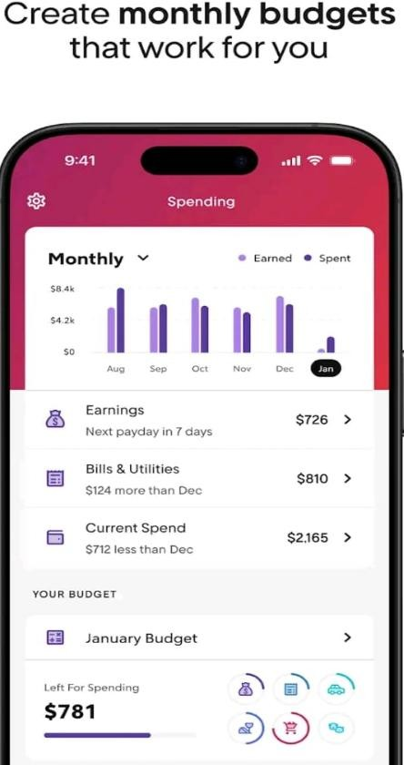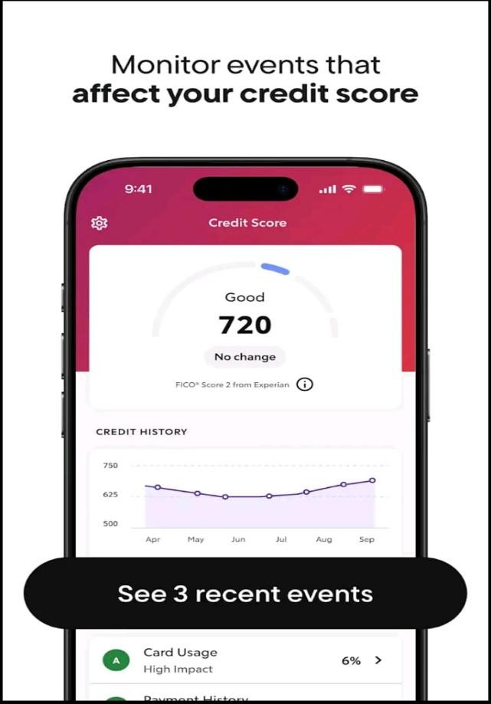

# b. Strengths and Weaknesses

**Strengths:**

* **Subscription Tracking:** Identifies and monitors recurring subscriptions.
* **Bill Negotiation:** Attempts to lower bills by negotiating with service providers.
* **Automated Expense Tracking:** Syncs with bank accounts to categorize expenses automatically.

**Weaknesses:**

* **Premium Features Require Payment:** While free to download, many features are locked behind a paywall.
* **Privacy Concerns:** Users must grant access to financial accounts, which may raise security concerns.

## c. Innovative Features

* **Smart Savings:** Uses AI to analyze spending and suggest ways to save money.
* **Automated Savings:** Transfers small amounts into savings accounts based on userdefined rules.

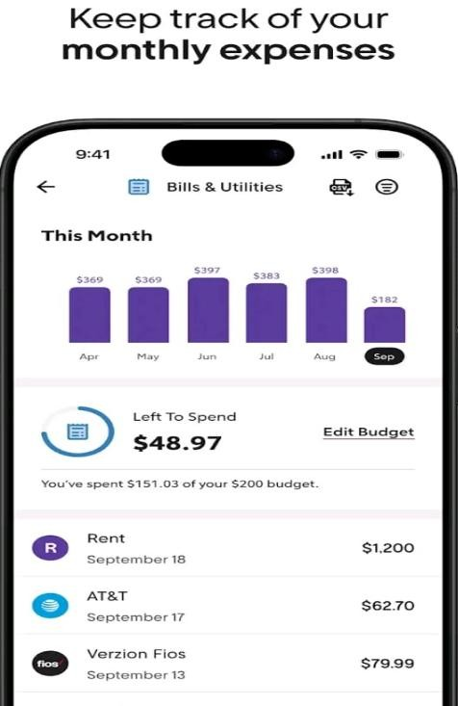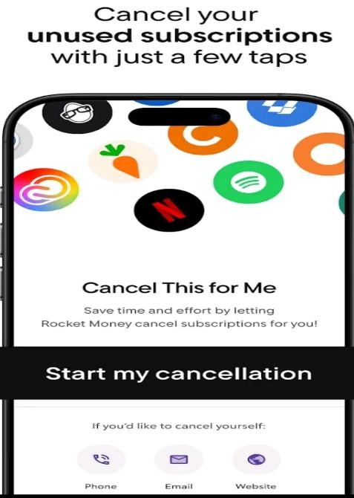

## 4. Visual Comparison (Infographic)

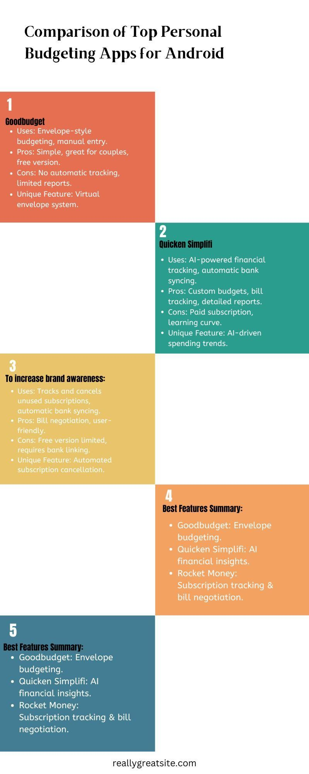

## 5. Desired Features for an Ideal Budgeting App

Based on the strengths of Goodbudget, Quicken Simplifi, and Rocket Money, the ideal budgeting app would include:

* **Automated Transaction Syncing:** Seamless integration with financial institutions.
* **Envelope Budgeting System:** Allow users to allocate funds into predefined categories.
* **Subscription Management:** Identify and cancel unwanted subscriptions.
* **Real-Time Updates:** Provide instant financial insights.
* **Cross-Platform Compatibility:** Ensure accessibility from various devices.

## 6. Conclusion

Using automated expense tracking, Rocket Money groups spending and provides perceptive analysis to help customers understand their financial behavior. For those who want to quickly save money and handle their money with minimum effort, even if some services demand a paid subscription is a great option.

**References:**

Business Insider(2025) Best Budgeting Apps for March 2025: Top Picks, Features, and Benefits.

Available at: <https://www.businessinsider.com/personal-finance/banking/best-budgeting-apps>[Accessed: 20 March 2025]

TechRadar (2025) Quicken Simplifi review . Available at: <https://www.techradar.com/pro/software-services/quicken-simplifi-review>[Accessed: 20 March 2025]

Modest Money (2024) Rocket Money vs Simplifi 2024. Available at: <https://www.modestmoney.com/rocket-money-vs-simplifi/> [Accessed: 20 March 2025]

FinanceBuzz (2025) Rocket Money vs. Quicken Simplifi [2025]: Low-Cost Budgeting Compared.

Available at: <https://financebuzz.com/rocket-money-vs-simplifi>[Accessed: 20 March 2025]

Modest Money (2025) *Rocket Money vs Quicken Simplifi - Best Budgeting App for 2025?***.**

[Online video]. Available at: <https://www.youtube.com/watch?v=J9O0W5LHzmI&ab_channel=ModestMoney>[Accessed: 26 March 2025]

Marble Jar Channel (2021) *Review of GoodBudget App* . [Online video]. Available at: <https://www.youtube.com/watch?v=z9O1CQ25lag&ab_channel=MarbleJarChannel>

[Accessed: 26 March 2025]